User Profile Maker Checker

  - List View – Search Screen

    - Maker Selection Criteria: User Clicks on the User Menu option ,
Selection criteria appear where the user can enter fields for Searching.

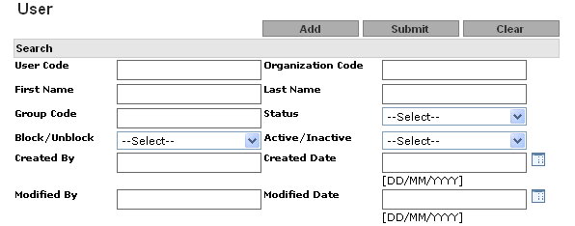

Field description for Search screen:

Seq No. | Field Name | Field Type | Description
1 | User Code | Text Field | Free text entry to enter user code
2 | Organization Code | Text Field | Free text entry to enter Organization Code
3 | First Name | Text Field | Free text entry to enter First Name
4 | Last Name | Text Field | Free text entry to enter Last Name
5 | Group Code | Text Field | Free text entry to enter Group Code
6 | Status | Drop down list | User can select status NEW, AUTHERIZED, MODIFIED, DELETED, REJECTED.
7 | Block/Unblock | Drop down list | Block/Unblock status
8 | Active/inactive | Drop down list | Active/inactive status
9 | Created By | Text Field | Free text entry to enter Created By
10 | Created Date | Date Popup | Free text entry to enter Created Date
11 | Modified By | Date Popup | Free text entry to enter Modified By
12 | Modified date | Date Popup | Free text entry to enter Modified date

    - User Maker Select List Criteria: User can click on User code and can view the status.
The screen should include following:
- Sorting on clicking on the header
- pagination at the bottom of the screen
  - 10 record per page should be displayed

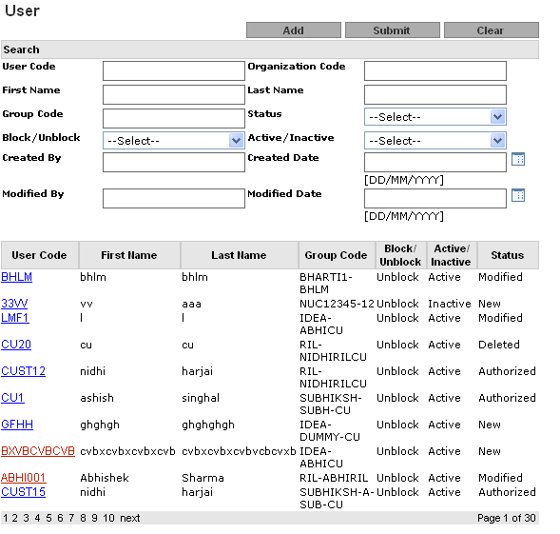

Sr No. | Field Name | Filed Type | Description
1 | User Code | Link | This will be a hyper link. While clicking on this hyperlink, a user can view the record’s details and then can perform further action on that record,  Such as Modify, Delete.
2 | First Name | Label | First Name
3 | Last Name | Label | Last Name
4 | Group Code | Label | Organization Code
5 | Block/Unblock | Label | Block/Unblock flag
6 | Active/ Inactive | Label | Active/ Inactive flag
7 | Status | Label | Record status

  - User Maker View On clicking the User Code hyperlink the user view page should be displayed. The details of the user view are given below.

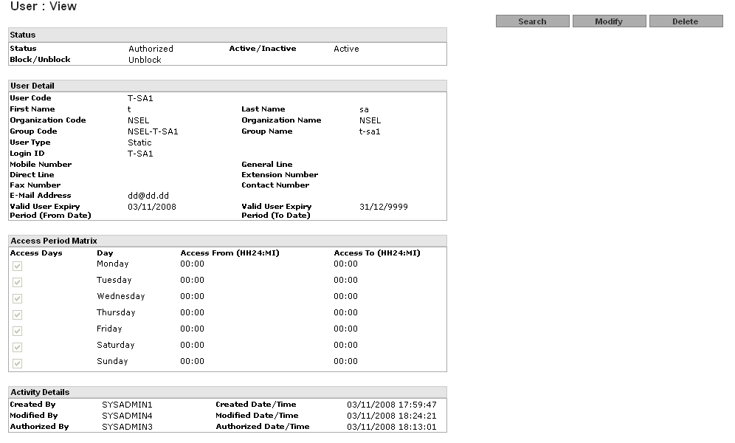

Status table
Seq No. | Field Name | Field Type | Description
1 | Status | Label | User can view status
2 | Active/Inactive | Label | User can view Active/Inactive
3 | Block/Unblock | Label | User can view Block/Unblock

User Detail
Seq No. | Field Name | Field Type | Description
1 | User Code | Label | User can view status
2 | First Name | Label | User can view Active/Inactive
3 | Last Name | Label | User can view Block/Unblock
4 | Organization Code | Label | User can view Organization code which is itself bank
5 | Organization Name | Label | User can view Organization Name which is itself bank
6 | Group Code | Label | User can view Group Code
7 | Group Name | Label | User can view Group Name
8 | User Type |  | User can view User Type
9 | Login ID |  | User can view Login ID
10 | Mobile number | Label | User can view Mobile number
11 | Contact Number | Label | User can view Contact Number
12 | Direct Line | Label | Direct Line User can view
13 | General Line | Label | General Line User can view
14 | Extension Number | Label | Extension Number User can view
15 | E-Mail Address | Label | E-Mail Address User can view
16 | Fax Number | Label | Fax Number User can view
17 | Valid User Expiry Period(From Date) | Label | User can view User Expiry Period
18 | Valid User Expiry Period(To Date) | Label | User can view User Expiry Period

Access Period Matrix
Seq No. | Field Name | Field Type | Description
1 | Access Days  → Sun  → Mon  → Tue  → Wed  → Thurs  → Fri  → Sat | Label | User can view working week days
2 | Access Time  (From Time) | Label | User can view Access Time
3 | Access Time  (To Time) | Label | User can view working week days
Activity Details
Sr No. | Field Name | Field Type | Description
1 | Created By | label | Created by Login ID
2 | Created date /Time | label | Created on date time
3 | Modified By | label | Authorize by Login ID
4 | Modified date/Time | label | Authorize on date time
5 | Authorize By | label | Authorize by Login ID
6 | Authorize Date/Time | label | Authorize on date time

  - User - Maker: Add:

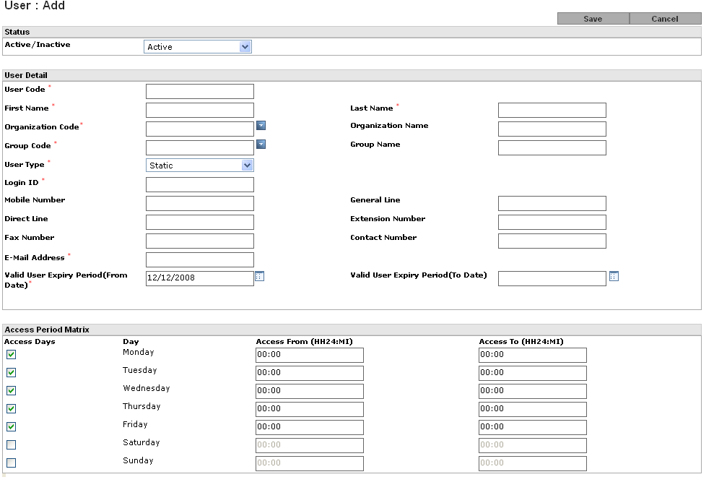

Validation Required:

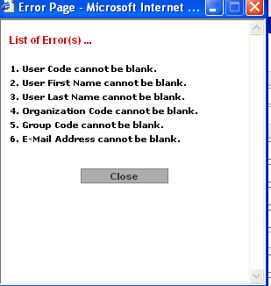

Organization Code Popup screen:

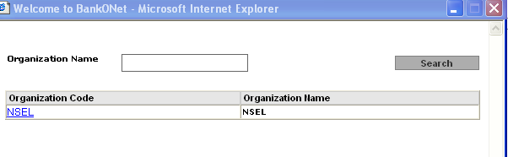

Group Code Popup screen
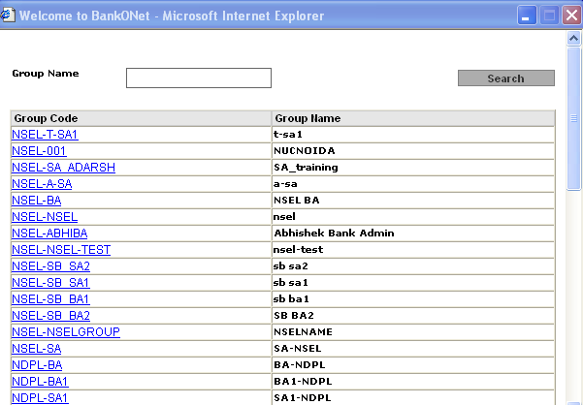

These following fields are available in this screen: -

Parameter Name | Data-Type/Size | Mandatory/Optional | Enable | Insert Allowed | Update Allowed | Field Type | Description/  Validation
Active / Inactive | A (1) | M |  |  |  | Drop-Down | Active / Inactive
User Code | A(20) | M | Y | Y | N | Text-Field | Unique User Code.
First Name | A(60) | M | Y | Y | Y | Text-Field | User First Name
Last Name | A(60) | M | Y | Y | Y | Text-Field | User Last Name
Organization Code | A | M | N | N | N | Non editable Text Field/popup | All active Organization code as mentioned above in Organization Code Popup screen.
Organization Name | A | M | N | N | N | Non editable Text Field | Name of the Organization. Comes based on organization code selected as shown in Organization Code Popup screen.
Group Code | A | M | N | N | Y | Non editable Text Field/popup | If user is tie to Group then this field should allow user to tie to the Group. When admin view the Group Mapping it should also display list of users tied to the Group- Mapping as shown above in Group Code popup screen.
Group Name | A | M | N | N | Y | Non editable Text Field | Will populate based on selected Group code as shown above in Group Code popup screen.
Login Id | A | M | N | N | N | Non Editable Text Field | This will be System generated once the user saves the record and User Code is Login ID for SA user.
User type | A(15) | M | Y | N | N | Drop down | User can select Static –Password generation option.
Mobile number | A(50) | O | Y | Y | Y | Text-Box | Mobile number of the particular user.  (Plain Text Field)
Contact Number | A (50) | O | Y | Y | Y | Text-Box | Contact Number of the particular user.  (Plain Text Field)
Direct Line | A(50) | O | Y | Y | Y | Text-Box | Direct Contact number of the particular user. (Plain Text Field)
General Line | A(50) | O | Y | Y | Y | Text-Box | General Contact number of the particular user. (Plain Text Field)
Extension No. | A(10) | O | Y | Y | Y | Text-Box | Extension number of the particular user.  (Plain Text Field)
E-Mail Address | A(100) | M | Y | Y | Y | Text-Box | E-Mail ID of the particular user.  (Plain Text Field)
Fax Number | A(50) | O | Y | Y | Y | Text-Field. | Fax Number of the particular user.  (Plain Text Field)
Valid User Expiry Period (From Date) | A(10) | M | Y | Y | Y | Text-Field. | BankONet will facilitate to mention user validity period as well (which can be mentioned in the form of Date Range: From Date & To Date).  <Expiry Period will be optional, Blank means, no expiry)
Valid User Expiry Period (To Date) | A(10) | O | Y | Y | Y | Text-Field | BankONet will facilitate to mention user validity period as well (which can be mentioned in the form of Date Range: From Date and To Date). If user does not enter any value the date will be set default to 9999.
Access Days  → Sun  → Mon  → Tue  → Wed  → Thurs  → Fri  → Sat | A | M | E | N | Y | Check box | Days will be selected/deselected thru’ Check-Box  BankONet will facilitate to mention the access days on User level. In other words, each user will have “Application Access Matrix” for each Day (like: Sun, Mon, Tue…….) with “From Time” and “To Time”.  (Default Working Days will be selected as Mon-Fri)
Access Time  (From Time) | A(5) | M | Y | Y | Y | Text-Field(s). | Default Value will be 00:00.  BankONet will facilitate to mention the access days on user level. In other words, each user will have “Application Access Matrix” for each Day (like: Sun, Mon, Tue…….) with “From Time” and “To Time”.
Access Time  (To Time) | A(5) | M | Y | Y | Y | Text-Field(s). | Default Value will be 00:00. (For all working days)  BankONet will facilitate to mention the access days on User level. In other words, each user will have “Application Access Matrix” for each Day (like: Sun, Mon, Tue…….) with “From Time” and “To Time”.

  - User Maker-Modify: Same Validation will be there as mentioned above in Add screen Table. Screen details as mentioned below

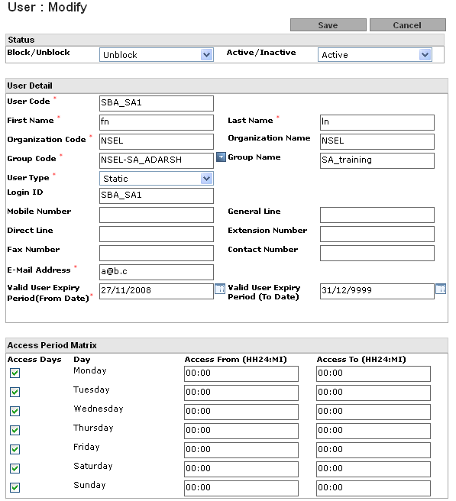

  - Maker Delete: A user record can be deleted using Delete functionality. (Once a User is deleted, it cannot be undeleted) as shown above Group Maker View.

  - User Checker:
Creation of a new user record/ changes in the existing user records will become effective for the system once the Authorizer authorizes it. Once the record has been rejected, the authorizer cannot access it. This will be done using Checker functionality of the system.

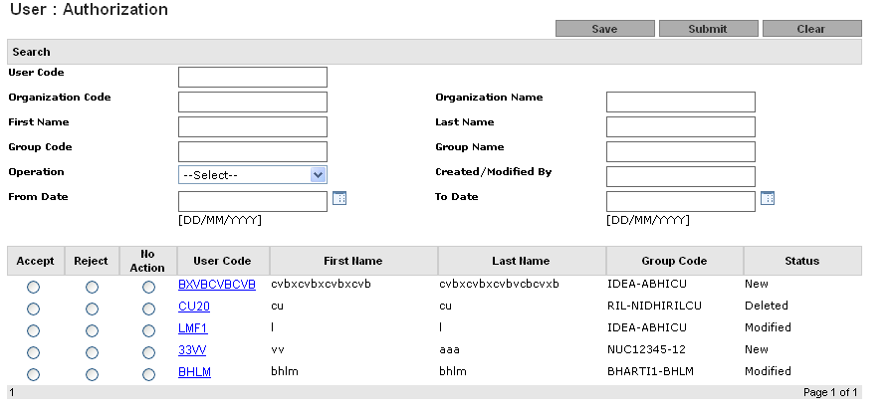

Seq Number | Field Name | Description
1 | Accept | This will be an option where Authorizer can Accept the record as an authorizer
2 | Reject | This will be an option where Authorizer can Reject the record
3 | No-Action | This will be an option where Authorizer does not want to perform any action on the modified record.
4 | User Code | This will be the hyper link. While clicking on this Hyper—Link, user can view the record’s operation detail.
5 | First Name | User Name
6 | Last Name | User Name
7 | Group Code | Group Code of the assigned group
8 | Status | The status of the record i.e. New/Modified

